J2EE Design Patterns
by Sue Spielman
01/16/2002
The term J2EE is tossed around a lot because it is a generic term that covers many areas of enterprise and distributed development. The J2EE modules and environment continue to grow as a rapid pace, and as many of you have come to learn, in recent years J2EE development has had its trials and tribulations.
For exactly this reason, it is important to take advantage of the most efficient and effective strategies for new development or the refactoring of existing projects. To keep up with the new developments, it is imperative that you aren't wasting time maintaining designs that have poor architecture or code that was poorly written.
This article covers how to use and identify design patterns, specifically for the presentation tier, in J2EE applications. The interest in design patterns has been around for a number of years in the software industry. However, interest among mainstream software developers is a fairly recent development -- and one that's long overdue, in my opinion. There are a number of reasons for this: it takes a highly experienced engineer to recognize a pattern; it requires collaboration; and it requires ongoing refinements. It also requires a sense of fluidity. Design patterns are not absolutes -- they are more expressions of proven solutions. It is up to you, the engineer or architect, to apply a pattern appropriately to your given scenario. This, of course, is easier said than done.
Patterns are not a magic pill. Just because a problem is observed and a pattern applied does not mean that you will have a perfect application -- or solution, for that matter. Patterns are a way of bringing clarity to a system architecture and they allow for the possibility of better systems being built. Building a system that meets the intended business requirements, performs well, is maintainable, and is delivered on time, is what keeps us engineers in business. Patterns have the distinct advantage of helping us do it all quicker.

So, what is a Design Pattern Anyway?
First of all, let's define what a design pattern is. There are a number of formal definitions, but I prefer a simple approach: a design pattern is simply a description of a recurring solution to a problem, given a context.
Simple enough. The context is the environment, surroundings, situation, or interrelated conditions within which the problem exists. Design patterns have a number of advantages, among which are:
- They capture engineering experience.
- Once described, any level engineer can use the pattern.
- They allow for reuse without having to reinvent the wheel on a project-by-project basis.
- They allow for us, as engineers, to better define system structure.
- They provide a design vocabulary.
- They also provide reusable artifacts.
It is a rare instance (although not an impossible one), that a design pattern is used in an isolated fashion. Typically, patterns have relationships and work together to form a weave, in that a pattern can be composed of, or rely on, other patterns. That is why you will see that the more familiar you are with different patterns, the better equipped you are to determine their interactions. Patterns can also form frameworks that can then be used for implementations.
Enterprise systems are built crossing many tiers; this should not be news to anyone reading this article. This discussion is focused on the presentation tier, and primarily covers patterns that can be used with JSP and Servlet technology.

Show Me Your Pattern
There are a number of patterns that have been identified by the Sun Java Center for the presentation tier. These are certainly not the only patterns that can be applied, but they are a good starting point. The presentation patterns take into consideration the logic required to service clients that access the system. This includes client requests, single sign-on, session management, access to business services, as well as the creation, formatting, and delivery of responses to the client. These patterns include:
- Intercepting Filter: facilitates preprocessing and post-processing of a request.
- Front Controller: provides a centralized controller for managing the handling of requests.
- View Helper: encapsulates logic that is not related to presentation formatting into Helper components.
- Composite View: creates an aggregate View from atomic subcomponents.
- Service To Worker: combines a Dispatcher component with the Front Controller and View Helper patterns.
- Dispatch View: combines a Dispatcher component with the Front Controller and View Helper patterns, deferring many activities to View processing.
While the patterns listed above might not mean anything to you now, by the time you finish this article, you will understand how using patterns to describe solutions will give you a clear understanding of the problem being discussed, just by the use of the pattern name. Think of the time that will be saved in meetings by just saying, "I think the View Helper can be applied here," instead of droning on about a complete problem description that we've all faced many times.

Helpful Hints
A couple of words of advice if you are just starting on your pattern odyssey.
If you haven't boned up on UML yet, the time is now. UML is quite commonly used to describe patterns in pattern catalogs, including class diagrams, sequence or interaction diagrams, and stereotypes. I'm not going to go into UML in this article, but I highly recommend getting up to speed on it.
When using patterns, it is important to define a naming convention. It will be much easier to manage a project as it grows and identify exactly what role an object plays by using such naming conventions. For example, if you are using the View Helper or Composite View patterns, you might want to define the naming convention to be [action]Helper.java or [action].jsp, respectively; for instance, CreatePageHelper.java or CreatePage.jsp.
Make a list of requirement statements that you will be addressing and then try to identify relevant patterns (once you are familiar with them) that might be applicable. By doing this, you will be amazed at how quickly you will start to recognize appropriate solutions to problems. For example:
- Requirement: I need one place of control for handling all requests.
Possible pattern: Front Controller Intercepting Filter.
- Requirement: I need a generic command interface for delegating processing from a controller to various helper components.
Possible pattern: Front Controller.
- Requirement: I want to make sure data related to my presentation formatting logic is encapsulated correctly.
Possible pattern: View Helper.
- Requirement: I need to be able to create one View from a number of sub-Views.
Possible pattern: Composite view.

And the Winner is…
In this section, we will briefly describe the presentation patterns mentioned so far. Most of these descriptions should invoke an "oh, yeah" response, as you identify situations you have faced during development. For a full pattern description, I highly recommend taking a look at Core J2EE Patterns (Alur, et al, Sun Microsystems Press, ISBN 0-13-064884-1) or "J2EE Blueprints."

Intercepting Filter
The Intercepting Filter intercepts incoming requests and outgoing responses, and applies a filter. Filters may be added and removed in a declarative manner, allowing them to be applied in a variety of combinations. After pre- or post-processing is finished, the final filter in the group passes control to the original target object, typically a Front Controller.

Front Controller
A Front Controller is a container that holds common processing logic that occurs within the presentation tier and that may otherwise be misplaced in a View. A controller handles requests and manages content retrieval, security, view management, navigation, and delegation to a Dispatcher component, which further dispatches to a View.

View Helper
View Helper encourages the separation of formatting-related code from other business logic. It suggests using Helper components to encapsulate logic relating to initiating content retrieval and validation, as well as adapting and formatting the model. The View component is then left to encapsulate the presentation formatting. Helper components typically delegate to Business Services (a business-tier pattern which we won't be discussing further).

Composite View
The Composite View composes a View from numerous pieces. Multiple smaller views, which could be either static or dynamic, are pieced together to create a single template.

Service to Worker and Dispatcher View
The Service to Worker and Dispatcher View patterns are a combination of other patterns. They share a common structure with common components, consisting of a controller working with a Dispatcher, Views, and Helpers, but the division of labor is different. The Dispatcher View defers content retrieval and error handling to the time of View processing. This pattern also suggests that the Dispatcher plays a more limited role in the View management, as the choice of the View is typically already included in the request.
You may already be using pattern-like strategies in your development process without even being aware of it. By identifying and becoming familiar with particular patterns, you will see that what might first appear as a problem that requires a roll-your-own solution might be better served by using a defined pattern. Let's explore a sample development scenario using the View Helper pattern and see how this might work.

Sample Scenario
Our scenario is a system that creates presentation content that requires processing of dynamic business data. This is a fairly common scenario to anyone doing J2EE development. The problem is that it is not uncommon for changes to occur in the presentation tier during the course of development. When business data logic and presentation-formatting logic are mingled together, the system becomes less flexible, harder to maintain, and provides a poor separation of tiers. Most of us -- even me -- are guilty at one point or another of coding Java into our JSPs. We want to avoid this situation.
Enter the View Helper pattern. The solution is to enforce this pattern so that the View contains formatting code, delegating its processing responsibilities to its helper classes. These classes might be implemented in a number of ways, including JavaBeans or custom tags. Helpers also store the View's intermediate data model and serve as business data adapters. It is important not to confuse a solution with its implementation strategy. For example, it's possible to implement this type of solution using a JSP View strategy, which uses a JSP as the View component. While this is a common strategy, it's also possible to take a Servlet View strategy, which uses a Servlet as a view instead. While we all know that a JSP actually becomes a Servlet, the strategy chosen becomes a matter of preference among the teams involved, as well as of the requirements of your project.
We have identified that we will use the View Helper pattern in our project. The class diagram for this pattern is shown in Figure 1.
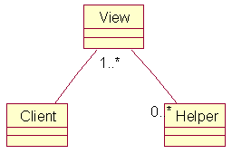
Figure 1.
The class diagram tells us what components we will need to create in order to realize this pattern. Remember the naming conventions we spoke about earlier! (As a side note, if you are working with Rational Rose, there are a number of patterns included in v2002 that allow for the actual classes that need to be realized for a pattern to be generated for you. Depending on the pattern you select, the appropriate classes are created. It's quite convenient.) By using a sequence diagram that represents the View Helper pattern, we are quickly able to see the logic flow.
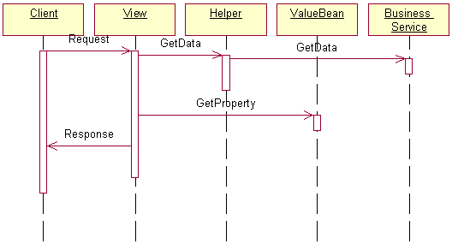
Figure 2.
The View represents and displays information to the client. Dynamic data is required, and the display is retrieved from a model. The helpers are used to support the View by encapsulating and adapting the model for displaying. A Helper is called a ValueBean if it is storing intermediate data from the model needed by the View. How the helper is implemented doesn't really matter; it could be a JavaBean or a custom tag, as we previously discussed. It could also be an XSL transformer, if XSL is being used for converting the model into the appropriate output for a specific client device. The Business Service is the service the client is trying to access -- the Business Service would typically branch off into another pattern specific to handling control and protection of the business service.
By using this pattern, we improve the tier partitioning and maintainability of our application by using helpers, as well as providing JavaBeans, custom tags, or XSL files that could very well be reused on other projects. The View Helper is also a good example of when a pattern is commonly used in conjunction with other patterns.
Take note: this is just the beginning. While this simple sequence diagram is a starting point, you will have to learn how to adapt your system modelling to your own development. Transforming patterns and strategies into an implementation is non-trivial. The more familiar you become with patterns, their strategies, and their implementation, the quicker you will be able to determine what you need for a specific project.

Summary
I hope this article has whet your appetite for using patterns in your development process. While this article only touched on presentation-tier patterns, there is a whole slew of patterns for the business and resource tiers that you should also become aware of (if you aren't already). By becoming familiar with patterns, as well as when and how to use them, you will ultimately become a better engineer. You will also find that your development process will improve, because you will more than likely be using tools that help create artifacts of your projects, including use-cases, sequence and class diagrams, and complete UML models of your systems.
For more information on design patterns, see this article, as well as the Core J2EE Patterns book and Sun's "J2EE Patterns" article.
Sue Spielman is an associate editor for ONJava.com, covering JSP and Servlets technologies. She is also President and Senior Consulting Engineer for Switchback Software LLC.

Each pattern in this catalog includes sample code from JavaTM BluePrints reference applications such as the Java Pet Store sample application.
Pattern Name | Description
Business Delegate [ACM01] | Reduce coupling between Web and Enterprise JavaBeansTM tiers
Composite Entity [ACM01] | Model a network of related business entities
Composite View [ACM01] | Separately manage layout and content of multiple composed views
Data Access Object (DAO) [ACM01] | Abstract and encapsulate data access mechanisms
Fast Lane Reader | Improve read performance of tabular data
Front Controller [ACM01] | Centralize application request processing
Intercepting Filter [ACM01] | Pre- and post-process application requests
Model-View-Controller | Decouple data representation, application behavior, and presentation
Service Locator [ACM01] | Simplify client access to enterprise business services
Session Facade [ACM01] | Coordinate operations between multiple business objects in a workflow
Transfer Object [ACM01] | Transfer business data between tiers
Value List Handler [ACM01] | Efficiently iterate a virtual list
View Helper [ACM01] | Simplify access to model state and data access logic

©
Core J2EE Pattern Catalog
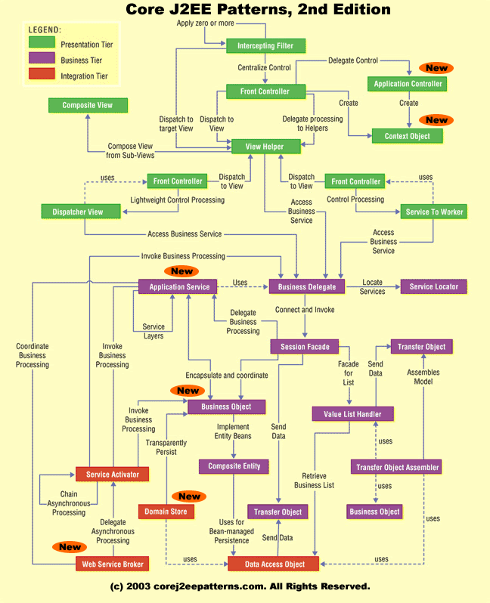
J2EE Pattern Relationships
Note: Please refer to the Pattern Relationships Diagram while reading the following text.
Intercepting Filter intercepts incoming requests and outgoing responses and applies a filter. These filters may be added and removed in a declarative manner, allowing them to be applied unobtrusively in a variety of combinations. After this preprocessing and/or post-processing is complete, the final filter in the group vectors control to the original target object. For an incoming request, this is often a Front Controller, but may be a View.
Front Controller is a container to hold the common processing logic that occurs within the presentation tier and that may otherwise be erroneously placed in a View. A controller handles requests and manages content retrieval, security, view management, and navigation, delegating to a Dispatcher component to dispatch to a View.
Application Controller centralizes control, retrieval, and invocation of view and command processing. While a Front Controller acts as a centralized access point and controller for incoming requests, the Application Controller is responsible for identifying and invoking commands, and for identifying and dispatching to views.
Context Object encapsulates state in a protocol-independent way to be shared throughout your application. Using Context Object makes testing easier, facilitating a more generic test environment with reduced dependence upon a specific container.
View Helper encourages the separation of formatting-related code from other business logic. It suggests using Helper components to encapsulate logic relating to initiating content retrieval, validation, and adapting and formatting the model. The View component is then left to encapsulate the presentation formatting. Helper components typically delegate to the business services via a Business Delegate or an Application Service, while a View may be composed of multiple subcomponents to create its template.
Composite View suggests composing a View from numerous atomic pieces. Multiple smaller views, both static and dynamic, are pieced together to create a single template. The Service to Worker and Dispatcher View patterns represent a common combination of other patterns from the catalog. The two patterns share a common structure, consisting of a controller working with a Dispatcher, Views, and Helpers. Service to Worker and Dispatcher View have similar participant roles, but differ in the division of labor among those roles. Unlike Service to Worker, Dispatcher View defers business processing until view processing has been performed.
Business Delegate reduces coupling between remote tiers and provides an entry point for accessing remote services in the business tier. A Business Delegate might also cache data as necessary to improve performance. A Business Delegate encapsulates a Session Façade and maintains a one-to-one relationship with that Session Façade. An Application Service uses a Business Delegate to invoke a Session Façade.
Service Locator encapsulates the implementation mechanisms for looking up business service components. A Business Delegate uses a Service Locator to connect to a Session Façade. Other clients that need to locate and connect to Session Façade, other business-tier services, and web services can use a Service Locator.
Session Façade provides coarse-grained services to the clients by hiding the complexities of the business service interactions. A Session Façade might invoke several Application Service implementations or Business Objects. A Session Façade can also encapsulate a Value List Handler.
Application Service centralizes and aggregates behavior to provide a uniform service layer to the business tier services. An Application Service might interact with other services or Business Objects. An Application Service can invoke other Application Services and thus create a layer of services in your application.
Business Object implements your conceptual domain model using an object model. Business Objects separate business data and logic into a separate layer in your application. Business Objects typically represent persistent objects and can be transparently persisted using Domain Store.
Composite Entity implements a Business Object using local entity beans and POJOs. When implemented with bean-managed persistence, a Composite Entity uses Data Access Objects to facilitate persistence.
The Transfer Object pattern provides the best techniques and strategies to exchange data across tiers (that is, across system boundaries) to reduce the network overhead by minimizing the number of calls to get data from another tier.
The Transfer Object Assembler constructs a composite Transfer Object from various sources. These sources could be EJB components, Data Access Objects, or other arbitrary Java objects. This pattern is most useful when the client needs to obtain data for the application model or part of the model.
The Value List Handler uses the GoF iterator pattern to provide query execution and processing services. The Value List Handler caches the results of the query execution and return subsets of the result to the clients as requested. By using this pattern, it is possible to avoid overheads associated with finding large numbers of entity beans. The Value List Handler uses a Data Access Object to execute a query and fetch the results from a persistent store.
Data Access Object enables loose coupling between the business and resource tiers. Data Access Object encapsulates all the data access logic to create, retrieve, delete, and update data from a persistent store. Data Access Object uses Transfer Object to send and receive data.
Service Activator enables asynchronous processing in your enterprise applications using JMS. A Service Activator can invoke Application Service, Session Façade or Business Objects. You can also use several Service Activators to provide parallel asynchronous processing for long running tasks.
Domain Store provides a powerful mechanism to implement transparent persistence for your object model. It combines and links several other patterns including Data Access Objects.
Web Service Broker exposes and brokers one or more services in your application to external clients as a web service using XML and standard web protocols. A Web Service Broker can interact with Application Service and Session Façade. A Web Service Broker uses one or more Service Activators to perform asynchronous processing of a request.
Presentation Tier

Intercepting Filter
Problem
You want to intercept and manipulate a request and a response before and after the request is processed.
Forces
- You want centralized, common processing across requests, such as checking the data-encoding scheme of each request, logging information about each request, or compressing an outgoing response.
- You want pre and postprocessing components loosely coupled with core request-handling services to facilitate unobtrusive addition and removal.
- You want pre and postprocessing components independent of each other and self contained to facilitate reuse.

Solution
Use an Intercepting Filter as a pluggable filter to pre and postprocess requests and responses. A filter manager combines loosely coupled filters in a chain, delegating control to the appropriate filter. In this way, you can add, remove, and combine these filters in various ways without changing existing code.
Class Diagram
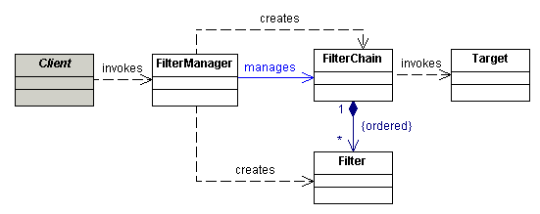
Sequence Diagram
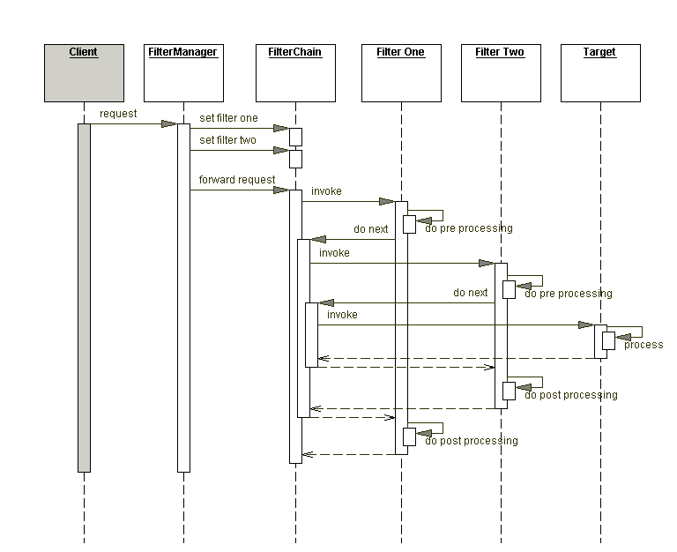
Strategies
- Standard Filter Strategy
- Custom Filter Strategy
- Base Filter Strategy
- Template Filter Strategy
- Web Service Message Handling Strategies
  - Custom SOAP Filter Strategy
  - JAX RPC Filter Strategy
Consequences
- Centralizes control with loosely coupled handlers
- Improves reusability
- Declarative and flexible configuration
- Information sharing is inefficient
Related Patterns
- Front Controller
The controller solves some similar problems, but is better suited to handling core processing.
- Decorator [GoF]
The Intercepting Filter is related to the Decorator, which provides for dynamically pluggable wrappers.
- Template Method [GoF]
The Template Method is used to implement the Template Filter strategy.
- Interceptor [POSA2]
The Intercepting Filter is related to the Interceptor, which allows services to be added transparently and triggered automatically.
- Pipes and Filters [POSA1]
The Intercepting Filter is related to Pipes and Filters.
Context Object
Problem
You want to avoid using protocol-specific system information outside of its relevant context.
Forces
- You have components and services that need access to system information.
- You want to decouple application components and services from the protocol specifics of system information.
- You want to expose only the relevant APIs within a context.
Solution
Use a Context Object to encapsulate state in a protocol-independent way to be shared throughout your application.
Class Diagram
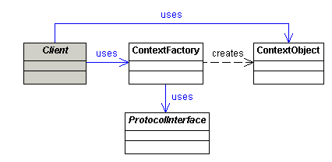
Sequence Diagram
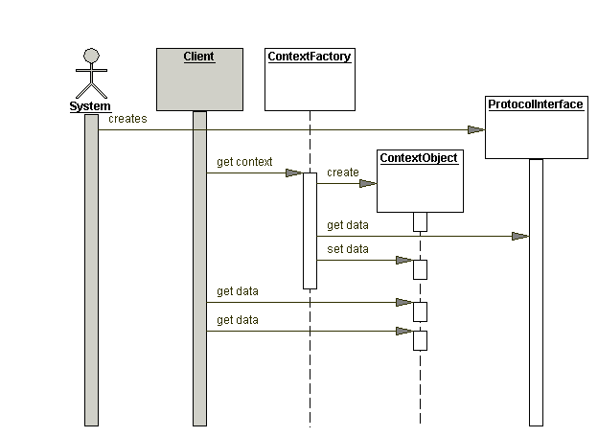
Strategies
- Request Context Strategies
  - Request Context Map Strategy
  - Request Context POJO Strategy
  - Request Context Validation Strategy
- Configuration Context Strategies
  - JSTL Configuration Strategy
  - Security Context Strategy
- General Context Object Strategies
  - Context Object Factory Strategy
  - Context Object Auto-Population Strategy
Consequences
- Improves reusability and maintainability
- Improves testability
- Reduces constraints on evolution of interfaces
- Reduces performance
Related Patterns
- Intercepting Filter
An Intercepting Filter can use a ContextFactory to create a Context Object during web request handling.
- Front Controller
A Front Controller can use a ContextFactory to create a Context Object during web request handling
- Application Controller
An Application Controller can use a ContextFactory to create a Context Object during web request handling
- Transfer Object
A Transfer Object is used specifically to transfer state across remote tiers to reduce network communication, while a Context Object is used to hide implementation details, improving reuse and maintainability.
Front Controller
Problem
You want a centralized access point for presentation-tier request handling.
Forces
- You want to avoid duplicate control logic.
- You want to apply common logic to multiple requests.
- You want to separate system processing logic from the view.
- You want to centralize controlled access points into your system.
Solution
Use a Front Controller as the initial point of contact for handling all related requests. The Front Controller centralizes control logic that might otherwise be duplicated, and manages the key request handling activities.
Class Diagram
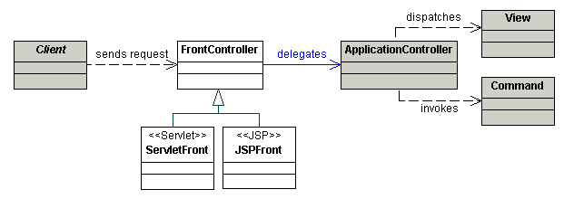
Sequence Diagram
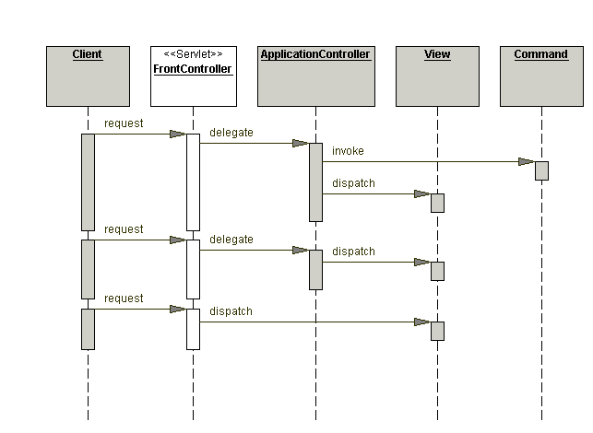
Strategies
- Servlet Front Strategy
- JSP Front Strategy
- Command and Controller Strategy
- Physical Resource Mapping Strategy
- Logical Resource Mapping Strategy
- Dispatcher in Controller Strategy
- Base Front Strategy
- Filter Controller Strategy
Consequences
- Centralizes control
- Improves manageability
- Improves reusability
- Improves role separation
Related Patterns
- Intercepting Filter
Both Intercepting Filter and Front Controller describe ways to centralize control of certain aspects of request processing.
- Application Controller
Application Controller encapsulates the action and view management code to which the controller delegates.
- View Helper
View Helper describes factoring business and processing logic out of the view and into helper objects and a central point of control and dispatch. Control-flow logic is factored forward into the controller and formatting-related code moves back into the helpers.
- Dispatcher View and Service to Worker
Dispatcher View and Service to Worker represent different usage patterns. Service to Worker is a controller-centric architecture, highlighting the Front Controller, while Dispatcher View is a view-centric architecture
Application Controller
Problem
You want to centralize and modularize action and view management.
Forces
- You want to reuse action and view-management code.
- You want to improve request-handling extensibility, such as adding use case functionality to an application incrementally.
- You want to improve code modularity and maintainability, making it easier to extend the application and easier to test discrete parts of your request-handling code independent of a web container.
Solution
Use an Application Controller to centralize retrieval and invocation of request-processing components, such as commands and views.
Class Diagram
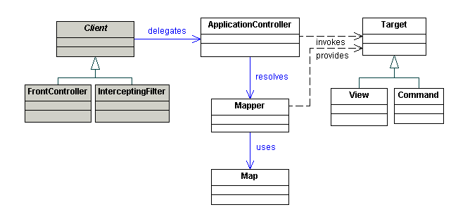
Sequence Diagram
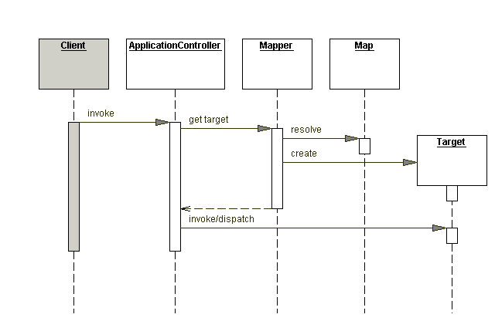
Strategies
- Command Handler Strategy
- View Handler Strategy
- Transform Handler Strategy
- Navigation and Flow Control Strategy
- Message Handling Strategies
- Custom SOAP Message Handling Strategy
- JAX RPC Message Handling Strategy
Consequences
- Improves modularity
- Improves reusability
- Improves extensibility
Related Patterns
- Front Controller
A Front Controller uses an Application Controller to perform action and view management.
- Service Locator
A Service Locator performs service location and retrieval. A Service Locator is a coarser object, often uses sophisticated infrastructure for lookup, and doesn’t manage routing. It also doesn’t address view management.
- Command Processor [POSA1]
A Command Processor manages command invocations, providing invocation scheduling, logging, and undo/redo functionality.
- Command Pattern [GoF]
A Command encapsulates a request in an object, separating the request from its invocation.
- Composite Pattern [GoF]
A Composite represents objects as part-whole hierarchies, treating individual objects and compositions of objects uniformly.
- Application Controller [PEAA]
Martin Fowler’s description of Application Controller [PEAA] seems to focus on controlling a user’s navigation through an application using a state machine, as described in the Navigation and Flow Control strategy. However, the Application Controller [PEAA] and our documentation of Application Controller have the same core intent.
View Helper
Problem
You want to separate a view from its processing logic.
Forces
- You want to use template-based views, such as JSP.
- You want to avoid embedding program logic in the view.
- You want to separate programming logic from the view to facilitate division of labor between software developers and web page designers.
Solution
Use Views to encapsulate formatting code and Helpers to encapsulate view-processing logic. A View delegates its processing responsibilities to its helper classes, implemented as POJOs, custom tags, or tag files. Helpers serve as adapters between the view and the model, and perform processing related to formatting logic, such as generating an HTML table.
Class Diagram
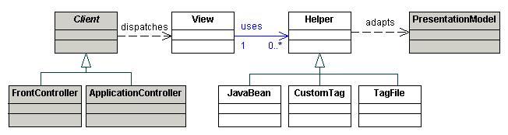
Sequence Diagram
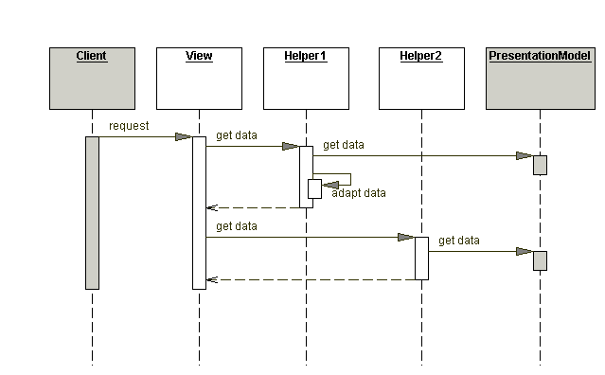
Strategies
- Template-Based View Strategy
- Controller-Based View Strategy
- JavaBean Helper Strategy
- Custom Tag Helper Strategy
- Tag File Helper Strategy
- Business Delegate as Helper Strategy
Consequences
- Improves application partitioning, reuse, and maintainability
- Improves role separation
- Eases testing
- Helper usage mirrors scriptlets
Related Patterns
- Front Controller
A Front Controller typically delegates to an Application Controller , to perform action and view management.
- Application Controller
An Application Controller manages view preparation and view creation, delegating to views and helpers.
- View Transform
An alternative approach to view creation is to perform a View Transform.
- Business Delegate
A Business Delegate reduces the coupling between a helper object and a remote business service, upon which the helper object can invoke.
Composite View
Problem
You want to build a view from modular, atomic component parts that are combined to create a composite whole, while managing the content and the layout independently.
Forces
- You want common subviews, such as headers, footers and tables reused in multiple views, which may appear in different locations within each page layout.
- You have content in subviews which might which frequently change or might be subject to certain access controls, such as limiting access to users in certain roles.
- You want to avoid directly embedding and duplicating subviews in multiple views which makes layout changes difficult to manage and maintain.
Solution
Use Composite Views that are composed of multiple atomic subviews. Each subview of the overall template can be included dynamically in the whole, and the layout of the page can be managed independently of the content.
Class Diagram
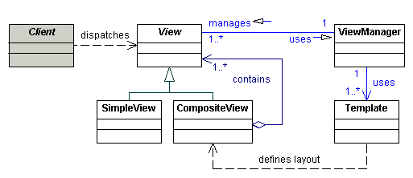
Sequence Diagram
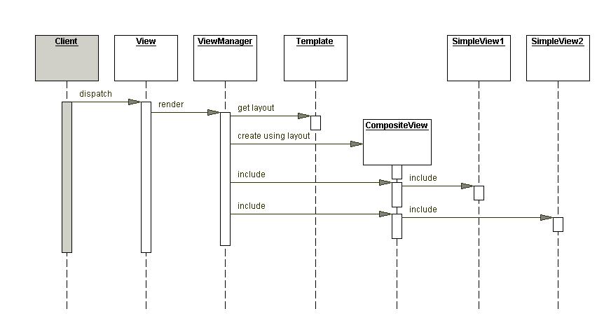
Strategies
- JavaBean View Management Strategy
- Standard Tag View Management Strategy
- Custom Tag View Management Strategy
- Transformer View Management Strategy
- Early-Binding Resource Strategy
- Late-Binding Resource Strategy
Consequences
- Improves modularity and reuse
- Adds role-based or policy-based control
- Enhances maintainability
- Reduces maintainability
- Reduces performance
Related Patterns
- View Helper
A Composite View can fulfill the role of View in View Helper.
- Composite [GoF]
A Composite View is based on Composite [GoF], which describes part-whole hierarchies where a composite object is composed of numerous subparts.

Dispatcher View
Problem
You want a view to handle a request and generate a response, while managing limited amounts of business processing.
Forces
- You have static views.
- You have views generated from an existing presentation model.
- You have views which are independent of any business service response.
- You have limited business processing.
Solution
Use Dispatcher View with views as the initial access point for a request. Business processing, if necessary in limited form, is managed by the views.
Class Diagram
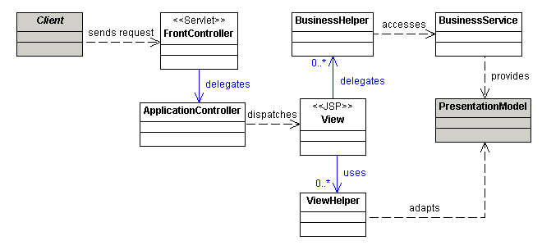
Sequence Diagram
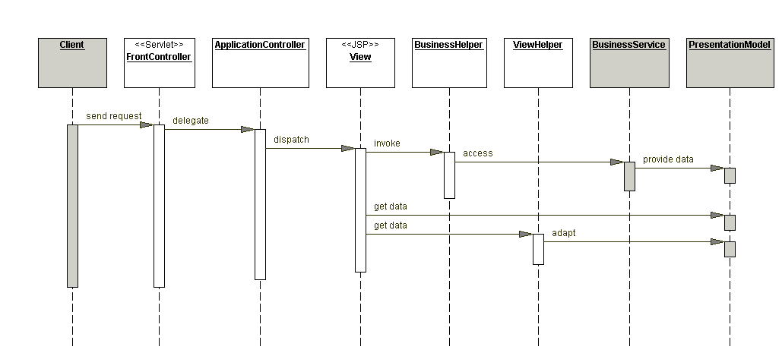
Strategies
- Servlet Front Strategy
- JSP Front Strategy
- Template-Based View Strategy
- Controller-Based View Strategy
- JavaBean Helper Strategy
- Custom Tag Helper Strategy
- Dispatcher in Controller Strategy
Consequences
- Leverages frameworks and libraries.
- Introduces potential for poor separation of the view from the model and control logic.
- Separates processing logic from view and improves reusability.
Related Patterns
- Front Controller
In a Dispatcher View approach, a Front Controller can handle the request or the request may be handled initially by the view.
- Application Controller
An Application Controller will often not be used with Dispatcher View. An Application Controller is used in those cases where limited view management is required to resolve an incoming request to the actual view.
- View Helper
Helpers mainly adapt and transform the presentation model for the view, but also help with any limited business processing that is initiated from the view.
- Composite View
The view can be a Composite View.
- Service to Worker
The Service to Worker approach centralizes control, request handling, and business processing before control is passed to the view. Dispatcher View, defers this behavior, if needed, to the time of view processing.
Service To Worker
Problem
You want to perform core request handling and invoke business logic before control is passed to the view.
Forces
- You want specific business logic executed to service a request in order to retrieve content that will be used to generate a dynamic response.
- You have view selections which may depend on responses from business service invocations.
- You may have to use a framework or library in the application.
Solution
Use Service to Worker to centralize control and request handling to retrieve a presentation model before turning control over to the view. The view generates a dynamic response based on the presentation model.
Class Diagram
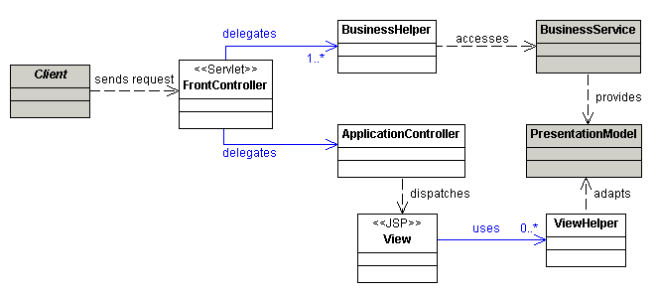
Sequence Diagram
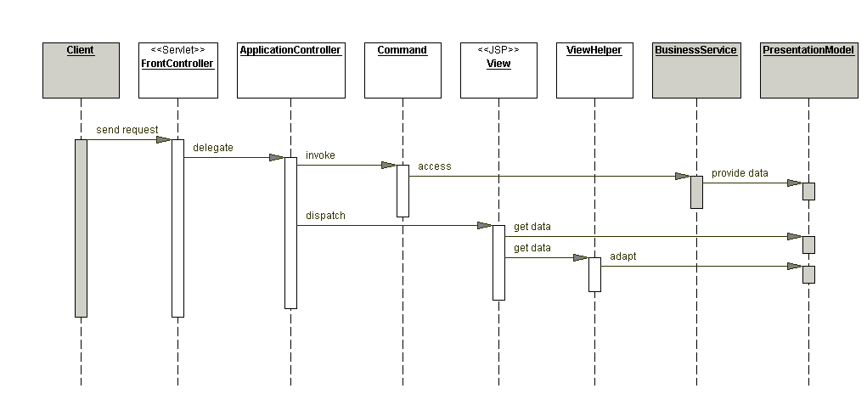
Strategies
- Servlet Front Strategy
- JSP Front Strategy
- Template-Based View Strategy
- Controller-Based View Strategy
- JavaBean Helper Strategy
- Custom Tag Helper Strategy
- Dispatcher in Controller Strategy
Consequences
- Centralizes control and improves modularity, reusability, and maintainability
- Improves role separation
Related Patterns
- Front Controller, Application Controller, and View Helper
Service to Worker is a controller-centric architecture, highlighting a Front Controller. The Front Controller delegates to an Application Controller for navigation and dispatch, then to view and helpers.
- Composite View
The view can be a Composite View.
- Business Delegate
A Business Delegate is used to hide any remote semantics of the business service.
- Dispatcher View
Dispatcher View is a view-centric architecture, where business processing is done after control is passed to the view.
- Business Delegate
A Business Delegate reduces the coupling between a helper object and a remote business service, upon which the helper object can invoke.
Business Tier

Business Delegate
Problem
You want to hide clients from the complexity of remote communication with business service components.
Forces
- You want to access the business-tier components from your presentation-tier components and clients, such as devices, web services, and rich clients.
- You want to minimize coupling between clients and the business services, thus hiding the underlying implementation details of the service, such as lookup and access.
- You want to avoid unnecessary invocation of remote services.
- You want to translate network exceptions into application or user exceptions.
- You want to hide the details of service creation, reconfiguration, and invocation retries from the clients.
Solution
Use a Business Delegate to encapsulate access to a business service. The Business Delegate hides the implementation details of the business service, such as lookup and access mechanisms.
Class Diagram
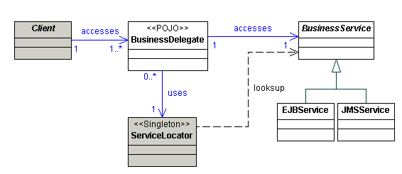
Sequence Diagram
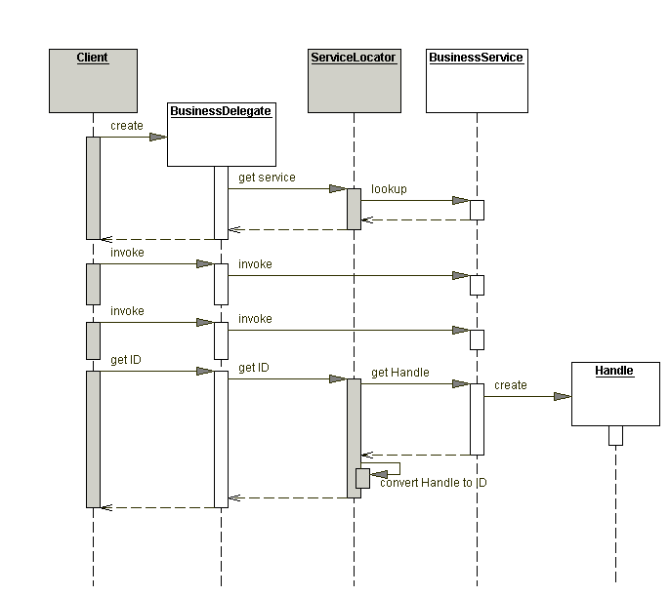
Strategies
- Delegate Proxy Strategy
- Delegate Adapter Strategy
Consequences
- Reduces coupling, improves maintainability
- Translates business service exceptions
- Improves availability
- Exposes a simpler, uniform interface to the business tier
- Improves performance
- Introduces an additional layer
- Hides remoteness
Related Patterns
- Service Locator
The Business Delegate typically uses a Service Locator to encapsulate the implementation details of business service lookup. When the Business Delegate needs to look up a business service, it delegates the lookup functionality to the Service Locator.
- Session Façade
For most EJB applications, the Business Delegate communicates with a Session Façade and maintains a one-to-one relationship with that facade. Typically, the developer who implements a Session Façade also provides corresponding Business Delegate implementations.
- Proxy [GoF]
A Business Delegate can act as a proxy, providing a stand-in for objects in the business tier. The Delegate Proxy strategy provides this functionality.
- Adapter [GoF]
A Business Delegate can use the Adapter design pattern to provide integration for otherwise incompatible systems.
- Broker [POSA1]
A Business Delegate acts as a Broker to decouple the business-tier objects from the clients in other tiers.
Service Locator
Problem
You want to transparently locate business components and services in a uniform manner.
Forces
- You want to use the JNDI API to look up and use business components, such as enterprise beans and JMS components, and services such as data sources.
- You want to centralize and reuse the implementation of lookup mechanisms for J2EE application clients.
- You want to encapsulate vendor dependencies for registry implementations, and hide the dependency and complexity from the clients.
- You want to avoid performance overhead related to initial context creation and service lookups.
- You want to reestablish a connection to a previously accessed enterprise bean instance, using its Handle object.
Solution
Use a Service Locator to implement and encapsulate service and component lookup. A Service Locator hides the implementation details of the lookup mechanism and encapsulates related dependencies.
Class Diagram
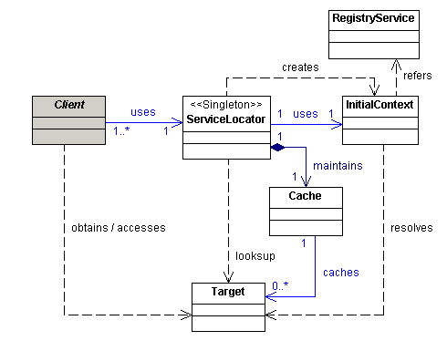
Sequence Diagram
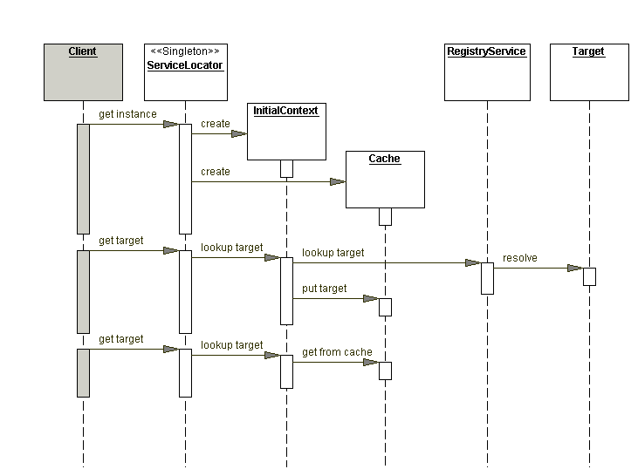
Strategies
- EJB Service Locator Strategy
- JDBC DataSource Service Locator Strategy
- JMS Service Locator Strategies
  - JMS Queue Service Locator Strategy
  - JMS Topic Service Locator Strategy
- Web Service Locator Strategy
Consequences
- Abstracts complexity
- Provides uniform service access to clients
- Facilitates adding EJB business components
- Improves network performance
- Improves client performance by caching
Related Patterns
- Business Delegate
Business Delegate uses a Service Locator to locate and obtain references to the business service objects, such as EJB objects, JMS topics, and JMS queues. This separates the complexity of service location from the Business Delegate, leading to loose coupling and increased manageability.
- Session Façade
Session Façade uses a Service Locator to locate and obtain home and remote references to the session beans and entity beans, as well as to locate a data source.
- Transfer Object Assembler
Transfer Object Assembler uses a Service Locator to locate references to session beans and entity beans that it needs to access data and build a composite transfer object.
- Data Access Object
A Data Access Object uses a Service Locator to look up and obtain a reference to a data source.
Session Façade
Problem
You want to expose business components and services to remote clients.
Forces
- You want to avoid giving clients direct access to business-tier components, to prevent tight coupling with the clients.
- You want to provide a remote access layer to your Business Objects (374) and other business-tier components.
- You want to aggregate and expose your Application Services (357) and other services to remote clients.
- You want to centralize and aggregate all business logic that needs to be exposed to remote clients.
- You want to hide the complex interactions and interdependencies between business components and services to improve manageability, centralize logic, increase flexibility, and improve ability to cope with changes.
Solution
Use a Session Façade to encapsulate business-tier components and expose a coarse-grained service to remote clients. Clients access a Session Façade instead of accessing business components directly.
Class Diagram
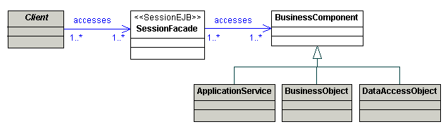
Sequence Diagram
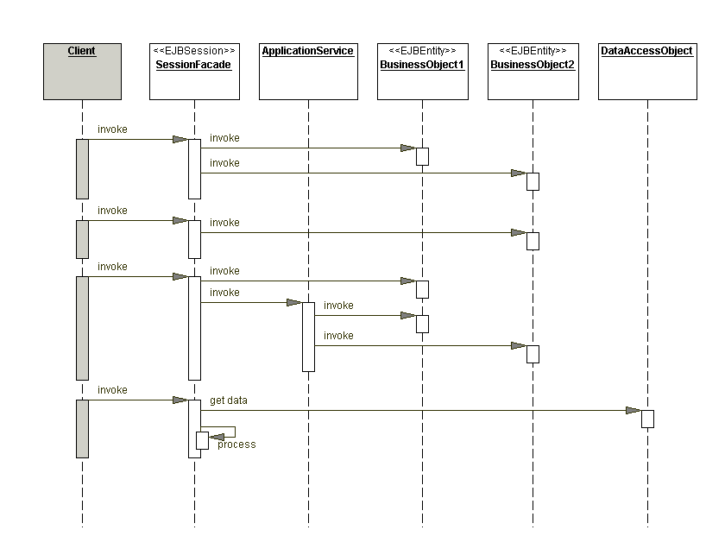
Strategies
- Stateless Session Façade Strategy
- Stateful Session Façade Strategy
Consequences
- Introduces a layer that provides services to remote clients
- Exposes a uniform coarse-grained interface
- Reduces coupling between the tiers
- Promotes layering, increases flexibility and maintainability
- Reduces complexity
- Improves performance, reduces fine-grained remote methods
- Centralizes security management
- Centralizes transaction control
- Exposes fewer remote interfaces to clients
Related Patterns
- Business Delegate
The Business Delegate is the client-side abstraction for a Session Façade. The Business Delegate proxies or adapts the client request to a Session Façade that provides the requested service.
- Business Object
The Session Façade encapsulates complex interactions of Business Objects that participate in processing a use case request.
- Application Service
In some applications, Application Services are used to encapsulate complex business logic and business rules. In these applications, the Session Façade implementations become simpler because they mostly delegate to Application Services and Business Objects.
- Data Access Object
The Session Façade might sometimes access a Data Access Object directly to obtain and store data. This is typical in simpler applications that do not use Business Objects. The Session Façades encapsulate trivial business logic and use Data Access Objects to facilitate persistence.
- Service Locator
The Session Façade can use a Service Locator to look up other business components, such as entity beans and session beans. This reduces the code complexity in the facade and leverages the benefits of the Service Locator pattern.
- Broker [POSA1]
The Session Façade performs the role of a Broker to decouple the Business Objects (374) and fine-grained services from their client tier.
- Facade [GoF]
The Session Façade is based on the Facade design pattern.
Application Service
Problem
You want to centralize business logic across several business-tier components and services.
Forces
- You want to minimize business logic in service facades.
- You have business logic acting on multiple Business Objects or services.
- You want to provide a coarser-grained service API over existing business-tier components and services.
- You want to encapsulate use case-specific logic outside of individual Business Objects.
Solution
Use an Application Service to centralize and aggregate behavior to provide a uniform service layer.
Class Diagram
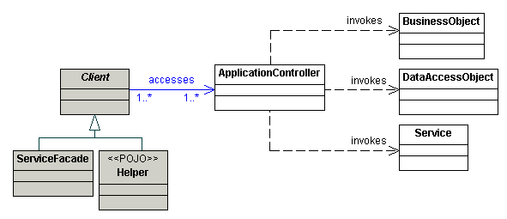
Sequence Diagram
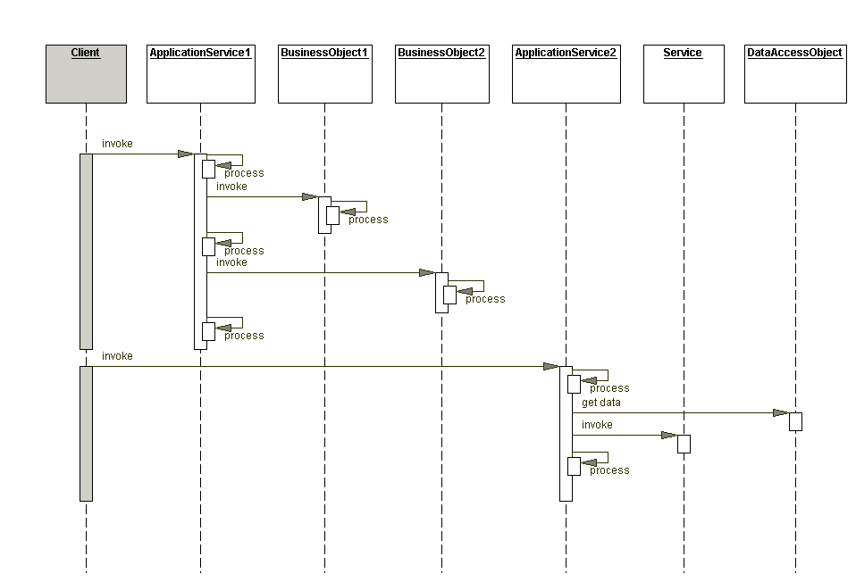
Strategies
- Application Service Command Strategy
- GoF Strategy for Application Service Strategy
- Application Service Layer Strategy
Consequences
- Centralizes reusable business and workflow logic
- Improves reusability of business logic
- Avoids duplication of code
- Simplifies facade implementations
- Introduces additional layer in the business tier
Related Patterns
- Session Façade
Application Services provide the background infrastructure for Session Façades, which become simpler to implement and contain less code because they can delegate the business processing to Application Services.
- Business Object
In applications that use Business Objects, Application Services encapsulate cross-Business Objects logic and interact with several Business Objects.
- Data Access Object
In some applications, an Application Service can use a Data Access Object directly to access data in a data store.
- Service Layer [PEAA]
Application Service is similar to Service Layer pattern in that both aim to promote a service layer in your application. Service Layer explains how a set of services can be used to create a boundary layer for your application.
- Transaction Script [PEAA]
When an Application Service is used without Business Objects (374), it becomes a service object where you can implement your procedural logic. Transaction Script describes the use of procedural approach to implementing business logic in your application.
Business Object
Problem
You have a conceptual domain model with business logic and relationship.
Forces
- You have a conceptual model containing structured, interrelated composite objects.
- You have a conceptual model with sophisticated business logic, validation and business rules.
- You want to separate the business state and related behavior from the rest of the application, improving cohesion and reusability.
- You want to centralize business logic and state in an application.
- You want to increase reusability of business logic and avoid duplication of code.
Solution
Use Business Objects to separate business data and logic using an object model.
Class Diagram
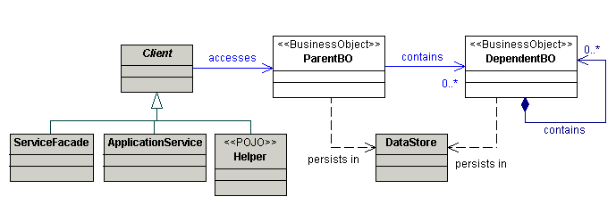
Sequence Diagram
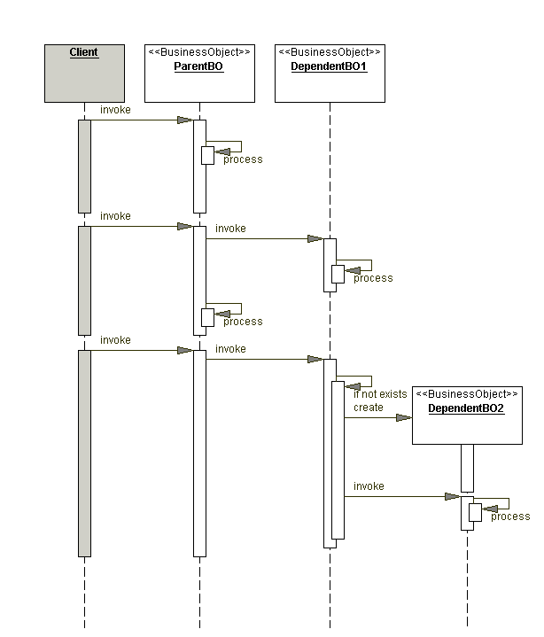
Strategies
- POJO Business Object Strategy
- Composite Entity Business Object Strategy
Consequences
- Promotes object-oriented approach to the business model implementation
- Centralizes business behavior and state, and promotes reuse
- Avoids duplication of and improves maintainability of code
- Separates persistence logic from business logic
- Promotes service-oriented architecture
- POJO implementations can induce, and are susceptible to, stale data
- Adds extra layer of indirection
- Can result in bloated objects
Related Patterns
- Composite Entity
You can implement Business Objects using local entity beans in EJB 2.x. Local entity beans are recommended over remote entity beans to implement Business Objects. Composite Entity discusses the details of implementing Business Objects with entity beans.
- Application Service
Atomic business logic and rules related to a single Business Object are typically implemented within that Business Object. However, in most applications, you also have business logic that acts on multiple Business Objects. You might also need to provide business behavior specific to use cases, client types, or channels on top of what the Business Objects inherently implement. Using Application Service is an excellent way to implement business logic that acts upon several Business Objects and thereby provides a service encapsulation layer for the Business Objects
- Transfer Object
You can use Transfer Objects to carry data to and from the Business Objects. Some developers are tempted to use Transfer Objects as the internal state representation for Business Objects. However, a Business Object wrapping a Transfer Object is not recommended because it violates the intention of the Transfer Object pattern and tightly couples the two types of objects. (See Business Object Wraps Transfer Object (Page 390)).
- Data Access Object
you can use Data Access Objects to facilitate Business Objects persistence, in implementations that use custom JDBC mechanisms.
- Domain Store
you can use Domain Store to provide Business Objects persistence to leverage the power of custom implementation of transparent persistence mechanisms, similar to standard JDO implementations.
- Transaction Script and Domain Model [PEAA]
Transaction Script discusses a procedural implementation of business logic and Domain Model discusses the object-oriented implementation. While the Domain Model and Business Object pattern are very similar, the term business object is more commonly used by developers and architects in the field and is more precise. We have seen extensive use of the term business object in numerous projects that fall in line with the concepts outlined in this pattern.
Composite Entity
Problem
You want to use entity beans to implement your conceptual domain model.
Forces
- You want to avoid the drawbacks of remote entity beans, such as network overhead and remote inter-entity bean relationships.
- You want to leverage bean-managed persistence (BMP) using custom or legacy persistence implementations.
- You want to implement parent-child relationships efficiently when implementing Business Objects as entity beans.
- You want to encapsulate and aggregate existing POJO Business Objects with entity beans.
- You want to leverage EJB container transaction management and security features.
- You want to encapsulate the physical database design from the clients.
Solution
Use a Composite Entity to implement persistent Business Objects using local entity beans and POJOs. Composite Entity aggregates a set of related Business Objects into coarse-grained entity bean implementations.
Class Diagram
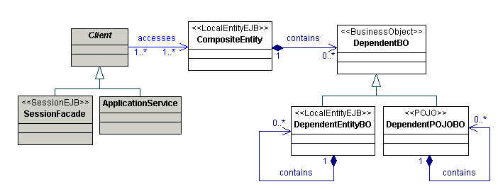
Sequence Diagram
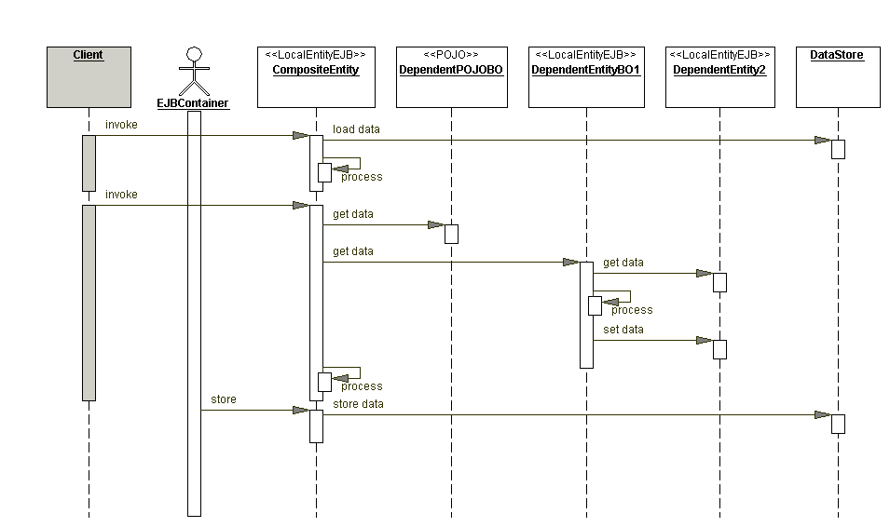
Strategies
- Composite Entity Remote Facade Strategy
- Composite Entity BMP Strategies
- Lazy Loading Strategy
- Store Optimization (Dirty Marker) Strategy
- Composite Transfer Object Strategy
Consequences
- Increases maintainability
- Improves network performance
- Reduces database schema dependency
- Increases object granularity
- Facilitates composite transfer object creation
Related Patterns
- Business Object
The Business Object pattern describes in general how domain model entities are implemented in J2EE applications. Composite Entity is one of the strategies of the Business Object pattern for implementing the Business Objects using entity beans.
- Transfer Object
The Composite Entity creates a composite Transfer Object and returns it to the client. The Transfer Object is used to carry data from the Composite Entity and its dependent objects.
- Session Façade
Composite Entities are generally not directly exposed to the application clients. Session Façades are used to encapsulate the entity beans, add integration and web service endpoints, and provide a simpler coarse-grained interface to clients.
- Transfer Object Assembler
when it comes to obtaining a composite transfer objects from the Business Object, the Composite Entity is similar to a Transfer Object Assembler. However, in this case, the data sources for all the Transfer Objects in the composite are parts of the Composite Entity itself, whereas for the Transfer Object Assembler, the data sources can be different entity beans, session beans, Data Access Objects, Application Services, and so on.
Transfer Object
Problem
You want to transfer multiple data elements over a tier.
Forces
- You want clients to access components in other tiers to retrieve and update data.
- You want to reduce remote requests across the network.
- You want to avoid network performance degradation caused by chattier applications that have high network traffic.
Solution
Use a Transfer Object to carry multiple data elements across a tier.
Class Diagram
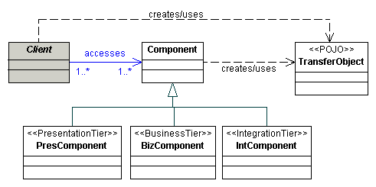
Sequence Diagram
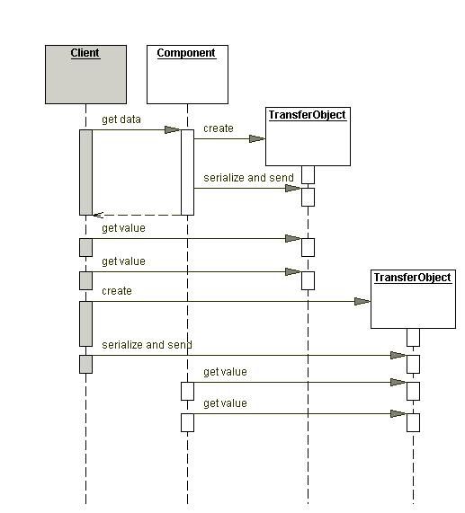
Strategies
- Updatable Transfer Objects Strategy
- Multiple Transfer Objects Strategy
- Entity Inherits Transfer Object Strategy
Consequences
- Reduces network traffic
- Simplifies remote object and remote interface
- Transfers more data in fewer remote calls
- Reduces code duplication
- Introduces stale transfer objects
- Increases complexity due to synchronization and version control
Related Patterns
- Session Façade
The Session Façade frequently uses Transfer Objects as an exchange mechanism with participating Business Objects. When the facade acts as a proxy to the underlying business service, the Transfer Object obtained from the Business Objects can be passed to the client.
- Transfer Object Assembler
The Transfer Object Assembler builds composite Transfer Objects from different data sources. The data sources are usually session beans or entity beans whose clients ask for data, and who would then provide their data to the Transfer Object Assembler as Transfer Objects. These Transfer Objects are considered to be parts of the composite object assembled by the Transfer Object Assembler.
- Value List Handler
The Value List Handler is another pattern that provides lists of dynamically constructed Transfer Objects by accessing the persistent store at request time.
- Composite Entity
The Transfer Object pattern addresses transferring data across tiers. This is one aspect of the design considerations for entity beans that can use the Transfer Object to carry data to and from the entity beans.
Transfer Object Assembler
Problem
You want to obtain an application model that aggregates transfer objects from several business components.
Forces
- You want to encapsulate business logic in a centralized manner and prevent implementing it in the client.
- You want to minimize the network calls to remote objects when building a data representation of the business-tier object model.
- You want to create a complex model to hand over to the client for presentation purposes.
- You want the clients to be independent of the complexity of model implementation, and you want to reduce coupling between the client and the business components.
Solution
Use a Transfer Object Assembler to build an application model as a composite Transfer Object. The Transfer Object Assembler aggregates multiple Transfer Objects from various business components and services, and returns it to the client.
Class Diagram
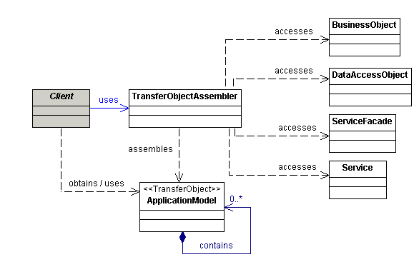
Sequence Diagram
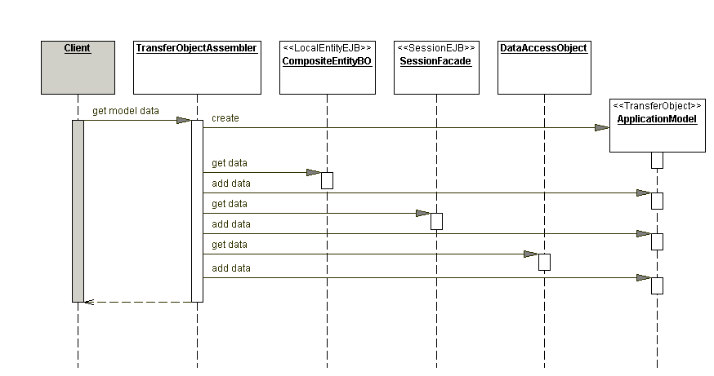
Strategies
- POJO Transfer Object Assembler Strategy
- Session Bean Transfer Object Assembler Strategy
Consequences
- Separates business logic, simplifies client logic
- Reduces coupling between clients and the application model
- Improves network performance
- Improves client performance
- Can introduce stale data
Related Patterns
- Transfer Object
The Transfer Object Assembler uses Transfer Objects to create and transport data to the client. The created Transfer Objects carry the data representing the application model from the business tier to the clients requesting the data.
- Business Object
The Transfer Object Assembler uses the required Business Objects to obtain data to build the required application model.
- Composite Entity
Composite Entity produces composite transfer objects from its own data. On the other hand, Transfer Object Assembler constructs the application model by obtaining data from different sources, such as Session Façades, Business Objects, Application Services, Data Access Objects, and other services.
- Session Façade
When Transfer Object Assembler is implemented as a session bean, you could view it as a limited special application of the Session Façade. If the client needs to update the business components that supply the application model data, it accesses a Session Façade (session bean) that provides that update service.
- Data Access Object
A Transfer Object Assembler can obtain certain data directly from the data store using a Data Access Object.
- Service Locator
The Transfer Object Assembler uses a Service Locator to locate and use various business components.
Value List Handler
Problem
You have a remote client that wants to iterate over a large results list.
Forces
- You want to avoid the overhead of using EJB finder methods for large searches.
- You want to implement a read-only use-case that does not require a transaction.
- You want to provide the clients with an efficient search and iterate mechanism over a large results set.
- You want to maintain the search results on the server side.
Solution
Use a Value List Handler to search, cache the results, and allow the client to traverse and select items from the results.
Class Diagram
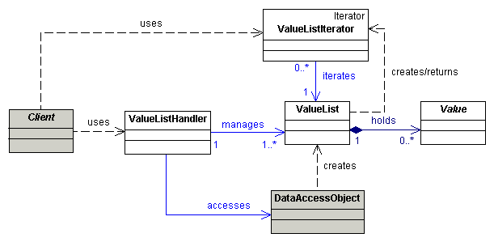
Sequence Diagram
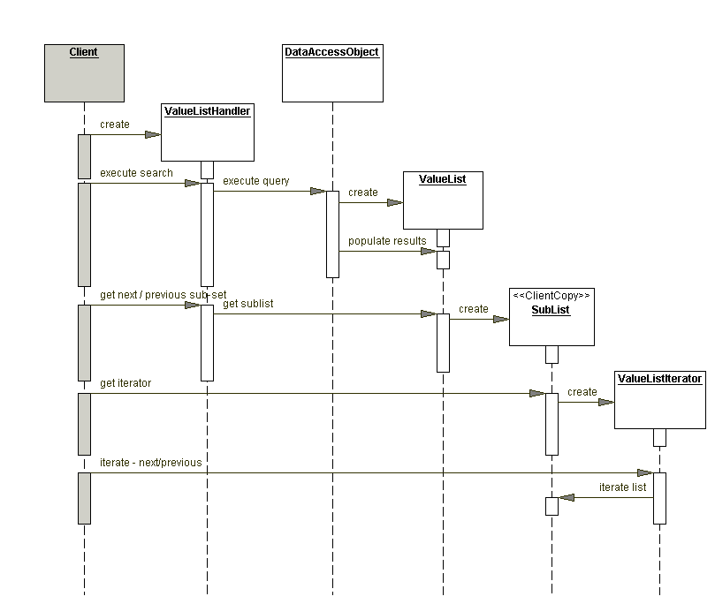
Strategies
- POJO Handler Strategy
- Value List Handler Session Façade Strategy
- Value List from Data Access Object Strategy
Consequences
- Provides efficient alternative to EJB finders
- Caches search results
- Provides flexible search capabilities
- Improves network performance
- Allows deferring entity bean transactions
- Promotes layering and separation of concerns
- Creating a large list of Transfer Objects can be expensive
Related Patterns
- Iterator [GoF]
This Value List Handler uses the Iterator pattern, described in the GoF book, Design Patterns: Elements of Reusable Object-Oriented Software.
- Data Access Object
This Value List Handler uses the Data Access Object to perform searches using either the DAO Transfer Object Collection strategy to obtain a collection of transfer objects or using the DAO RowSet Wrapper List strategy to obtain a custom List implementation.
- Session Façade
The Value List Handler is often implemented as a specialized version of the Session Façade responsible for managing the search results and providing a remote interface. Some applications might have Session Façades that expose other business methods and also include the functionality of the Value List Handler. However, it might be better to keep the list handling functionality of the Value List Handler separate from the business methods of a Session Façade. Thus, if the Value List Handler needs a remote interface, provide a dedicated session bean implementation that encapsulates and facades the Value List Handler.
Integration Tier

Data Access Object
Problem
You want to encapsulate data access and manipulation in a separate layer.
Forces
- You want to implement data access mechanisms to access and manipulate data in a persistent storage.
- You want to decouple the persistent storage implementation from the rest of your application.
- You want to provide a uniform data access API for a persistent mechanism to various types of data sources, such as RDBMS, LDAP, OODB, XML repositories, flat files, and so on.
- You want to organize data access logic and encapsulate proprietary features to facilitate maintainability and portability.
Solution
Use a Data Access Object to abstract and encapsulate all access to the persistent store. The Data Access Object manages the connection with the data source to obtain and store data.
Class Diagram
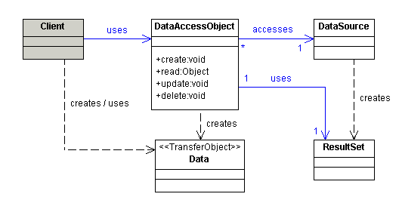
Sequence Diagram
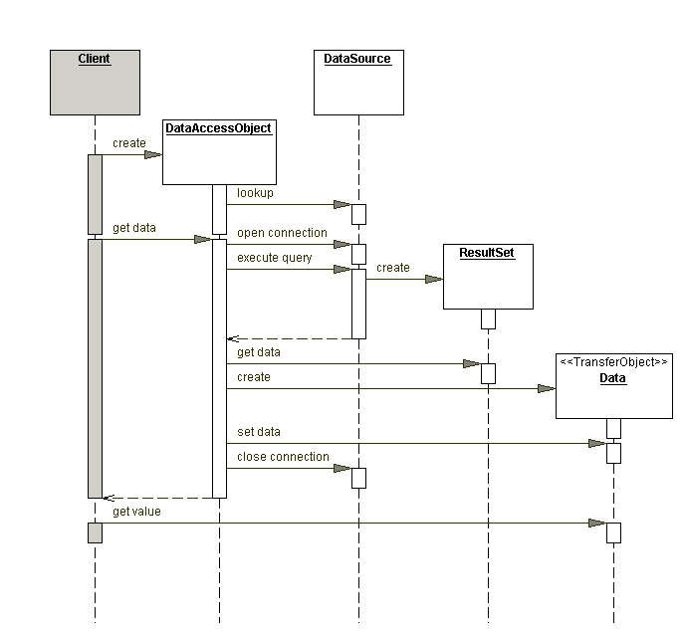
Strategies
- Custom Data Access Object Strategy
- Data Access Object Factory Strategies
- Transfer Object Collection Strategy
- Cached RowSet Strategy
- Read Only RowSet Strategy
- RowSet Wrapper List Strategy
Consequences
- Centralizes control with loosely coupled handlers
- Enables transparency
- Provides object-oriented view and encapsulates database schemas
- Enables easier migration
- Reduces code complexity in clients
- Organizes all data access code into a separate layer
- Adds extra layer
- Needs class hierarchy design (Factory Method Strategies)
- Introduces complexity to enable object-oriented design (RowSet Wrapper List Strategy)
Related Patterns
- Transfer Object
Data access objects in their most basic form use transfer objects to transport data to and from their clients. Transfer Object are used in other strategies of Data Access Objects. The RowSet Wrapper List strategy returns a list as a transfer object.
- Factory Method [GoF] and Abstract Factory [GoF]
The Data Access Object Factory strategies use the Factory Method pattern to implement the concrete factories and its products (DAOs). For added flexibility, the Abstract Factory pattern is used as described in the Data Access Object Factory strategy.
- Broker [POSA1]
The DAO pattern is related to the Broker pattern, which describes approaches for decoupling clients and servers in distributed systems. The DAO pattern more specifically applies this pattern to decoupling the resource tier from clients in another tier, such as the business or presentation tier.
- Transfer Object Assembler
The Transfer Object Assembler uses the Data Access Object to obtain data to build the composite transfer object it needs to assemble and send as the model data to the client.
- Value List Handler
The value list handler needs a list of results to act upon. Such a list is often obtained using a Data Access Object, which can return a set of results. While the value list handler has an option of obtaining a RowSet from the Data Access Object, it might be better to obtain and use a RowSet Wrapper List instead.
Real World Product / Implementation
- CodeFutures adopts and implements the DAO Pattern in their Firestorm DAO product. Check out their product here.
- 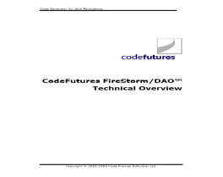
Service Activator
Problem
You want to invoke services asynchronously.
Forces
- You want to invoke business services, POJOs, or EJB components in an asynchronous manner.
- You want to integrate publish/subscribe and point-to-point messaging to enable asynchronous processing services.
- You want to perform a business task that is logically composed of several business tasks.
Solution
Use a Service Activator to receive asynchronous requests and invoke one or more business services.
Class Diagram
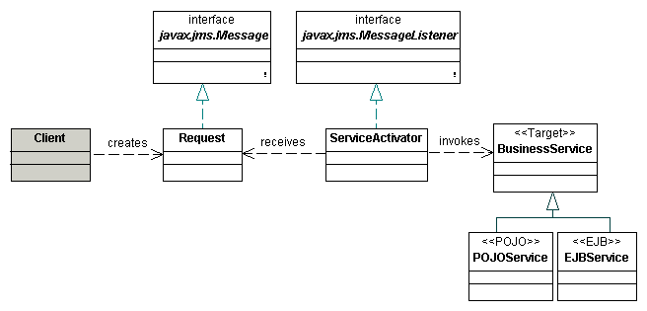
Sequence Diagram
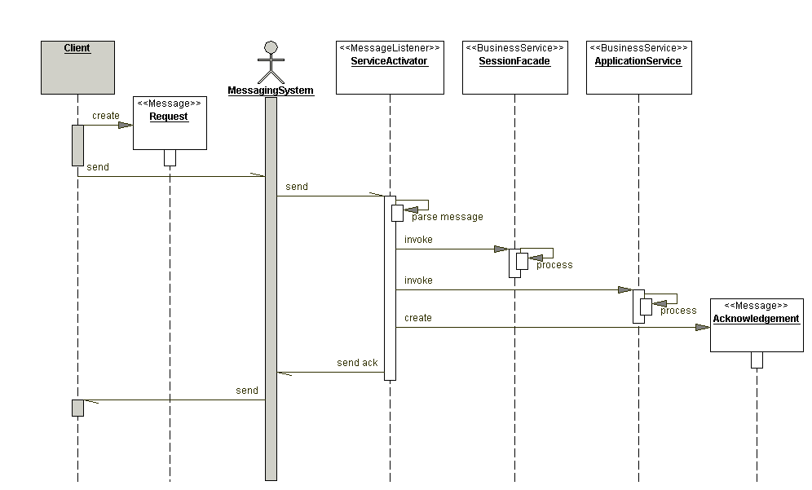
Strategies
- POJO Service Activator Strategy
- MDB Service Activator Strategy
- Service Activator Aggregator Strategy
- Response Strategies
  - Database Response Strategy
  - Email Response Strategy
  - JMS Message Response Strategy
Consequences
- Integrates JMS into enterprise applications
- Provides asynchronous processing for any business-tier component
- Enables standalone JMS listener
Related Patterns
- Session Façade
The Session Façade encapsulates the complexity of the system and provides coarse-grained access to business objects. A Service Activator can access a Session Façade as a business service to invoke business processing.
- Application Services
An Application Service can also be a kind of business service that a Service Activator invokes to process the request.
- Business Delegate
The Service Activator typically uses a Business Delegate to access a Session Façade. This results in simpler code for the Service Activator and results in Business Delegate reuse across different tiers.
- Service Locator
The client can use the Service Locator pattern to look up and create JMS-related service objects. The Service Activator can use the Service Locator pattern to look up and create enterprise bean components.
- Half-Sync/Half-Async [POSA2]
The Service Activator is related to the Half-Sync/Half-Async pattern. The pattern describes architectural decoupling by suggesting different layers for synchronous and asynchronous processing, and an intermediate queuing layer in between.
- Aggregator [EIP]
The Aggregator pattern discusses the problem of converting a request into several asynchronous tasks and aggregating the results. The Service Activator Aggregator strategy is based on similar concepts.
Domain Store
Problem
You want to separate persistence from your object model.
Forces
- You want to avoid putting persistence details in your Business Objects.
- You do not want to use entity beans.
- Your application might be running in a web container.
- Your object model uses inheritance and complex relationships.
Solution
Use a Domain Store to transparently persist an object model. Unlike J2EE’s container-managed persistence and bean-managed persistence, which include persistence support code in the object model, Domain Store's persistence mechanism is separate from the object model.
Class Diagram
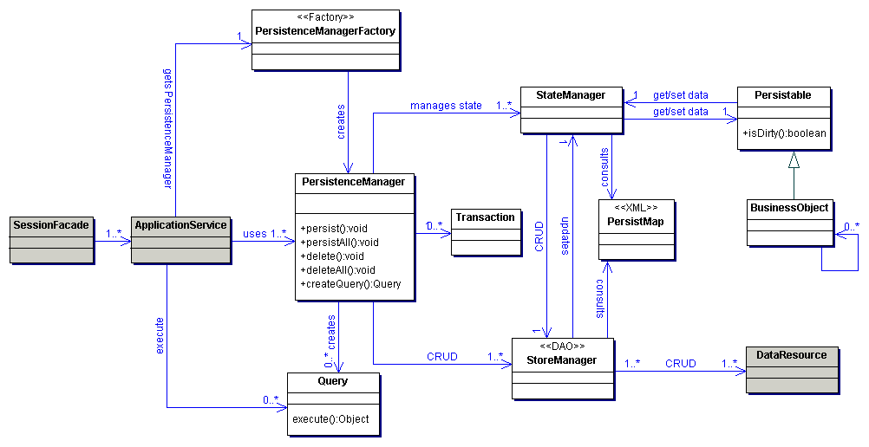
Sequence Diagram
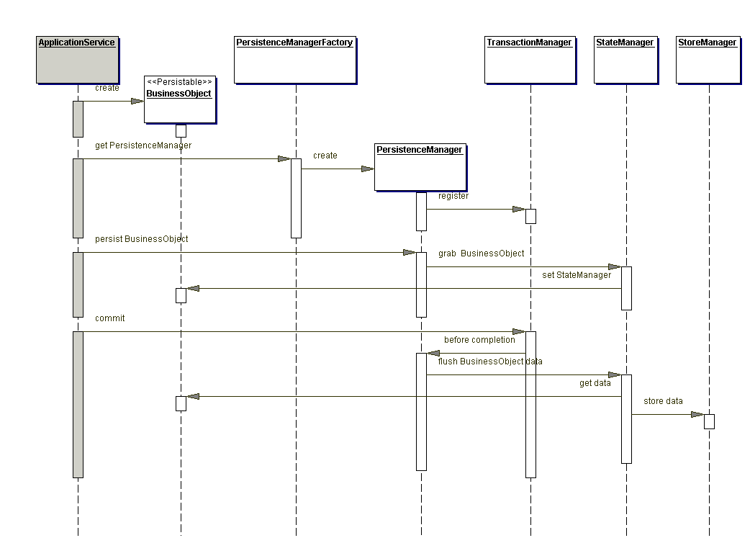
Strategies
- Custom Persistence Strategy
- JDO Strategy
Consequences
- Creating a custom persistence framework is a complex task
- Multi-layer object tree loading and storing requires optimization techniques
- Improves understanding of persistence frameworks
- A full-blown persistence framework might be overkill for a small object model
- Improves testability of your persistent object model
- Separates business object model from persistence logic
Related Patterns
- Unit of Work [PEAA]
Maintains a list objects affected by a business transaction. Unit of Work closely relates to PersistenceManager.
- Query Object [PEAA]
An object that represents a database query. Relates to the Query role described in Domain Store.
- Data Mapper [PEAA]
A layer of Mappers that moves data between objects and database. Relates to StateManager.
- Table Data Gateway [PEAA]
An object that acts as gateway to a database table. Relates to StoreManager.
- Dependent Mapping [PEAA]
Has one class perform the database mapping for a child class. Relates to parent dependent object and PersistMap.
- Domain Model [PEAA]
An object model that has behavior and data. Relates to BusinessObject.
- Data Transfer Object [PEAA]
Same as Transfer Object.
- Identity Map [PEAA]
Ensures each object only gets loaded once. Relates to StateManager.
- Lazy Load [PEAA]
An object which contains partial data and knows how to get complete data. Relates to StateManager and StoreManager interaction for lazy loading.
Web Service Broker
Problem
You want to provide access to one or more services using XML and web protocols.
Forces
- You want to reuse and expose existing services to clients.
- You want to monitor and potentially limit the usage of exposed services, based on your business requirements and system resource usage.
- Your services must be exposed using open standards to enable integration of heterogeneous applications.
- You want to bridge the gap between business requirements and existing service capabilities
Solution
Use a Web Service Broker to expose and broker one or more services using XML and web protocols.
Class Diagram
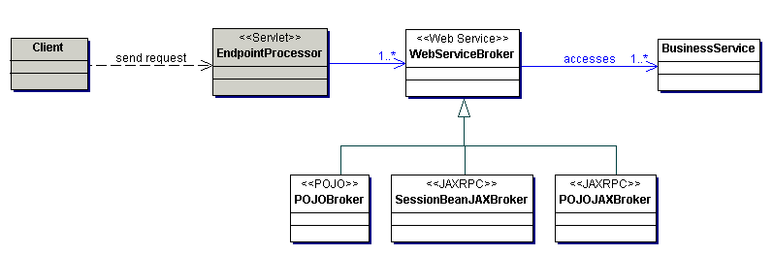
Sequence Diagram
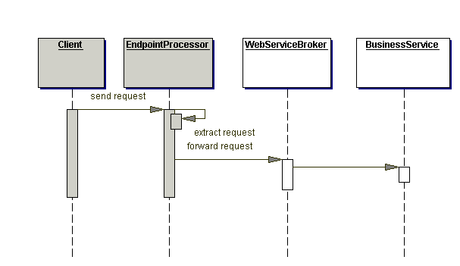
Strategies
- Custom XML Messaging Strategy
- Java Binder Strategy
- JAX-RPC Strategy
Consequences
- Introduces a layer between client and service
- Existing remote Session Façades (341) need be refactored to support local access
- Network performance may be impacted due to web protocols
Related Patterns
- Aggregator [EIP]
- Application Service
Application Service components can be called from Web Service Broker components.
- Session Façade
Session Façade components can be called from Web Service Broker components.
- Mediator [POSA1]
Mediator is a hub for interaction like Web Service Broker
- Message Router [EIP]

